NOSEWORK AND OBEDIENCE SEMINARS
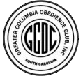 with JULIE SYMONS
Are you always torn whether to work on nosework skills or obedience skills? Not sure which seminar you should go to? Well, now you can have both in one weekend with the Greater Columbia Obedience Club!
Saturday, December 9, 2017 – Nosework
Sunday, December 10, 2017 – Obedience Games

Nosework
Join the sport that is taking the dog world by storm! Everyone loves playing hide and seek, and now you and your dog can play together. Julie will share information about how to train a dog to find hidden odors, as well as provide knowledge to the human half of the team. Working teams will include both novice and more advanced teams, so there will be something for everyone.

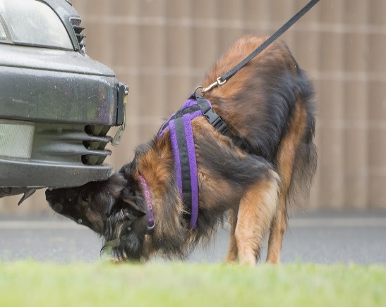
Obedience Games
Join us for a full day of playing obedience games! Short, fun, and fast paced games will be presented for all levels of competition obedience training. Julie will share a wealth of training knowledge and games to engage and motivate your dog. Instead of formal training we will learn ways to mix up our sessions and be more unpredictable. By adding “game training” with less predictability and formality, we build relationship and transfer reinforcement to the act of playing!

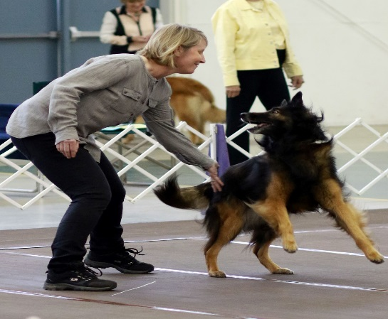
Biography
Julie Symons has been involved in dog sports for over 20 years. Starting with her mix Dreyfus in flyball in the early 1990s, she went on to train and compete in conformation, agility, obedience, herding and tracking with her Novice A dog Rival. Rival was the first CH OTCH MACH Belgian Tervuren and they competed and placed in many regional and national events. Julie’s current Belgian Tervuren Savvy is also a breed and agility champion, in addition to earning their TDX, UD and NW3-Eliite titles over the last few years. Her newest training companion is Drac, her 22month old Belgian Malinois. He is well on his way to being a versatile team player, having earned his NW1 earlier this year and training in tracking, obedience and agility.
One of Julie’s favorite things is a versatile team! She truly believes that participating in multiple sports is enriching to both person and dog and builds on that mutual partnership and trust. She is a consummate learner and energetic instructor, immersing herself in everything dog training! While teaching agility in the early 2000s, she found how rewarding it was to teach and help others. The simple truth? People just really love their dogs and enjoy doing activities with them. Knowing this helps set the tone for how she instructs; giving students ample working time, staying positive when things get challenging, and giving more than 100% of her efforts toward their development.
REGISTRATION INFORMATION
Registration opens Seminar Location
Club members - Sept 25, 2017 Greater Columbia Obedience Club
Non-club members - Oct 9, 2017 947 S Stadium Rd, #10
Please register at gcoc.net Columbia, SC
Saturday, December 9: Nosework
Full day AUDIT spot = $75 (all)
-unlimited number of audit spots
1/2 day WORKING spot, 1/2 day audit spot (Novice dogs) = $110 (club members), $125 (non-club members)
-maximum of 7 novice working teams
- Novice = dog must already be searching for odor and working toward ORT and novice/Level 1 trialing. Ideal for teams wanting to get trial ready and gain more element and handling skills.

1/2 day WORKING spot, 1/2 day audit spot (Advanced dogs) = $110 (club members), $125 (non-club members)
-maximum of 7 advanced working teams
- Advanced = have ORT and trialing or ready to trial. Ideal for teams needing some handling polishing, and ready to learn advanced skills.
For the Nosework seminar ONLY, working dogs will work for 1/2 the day. The other half of the day will be auditing. Please see the criteria above to determine whether your dog should be with the Novice working group or the Advanced working group.

Sunday, December 10: Obedience Games
Full day AUDIT spot = $75 (all)
-unlimited number of audit spots
Full day WORKING spot = $150 (club members), $175 (non-club members)
-maximum of 10 working teams
QUESTIONS? Please contact Nicole Tate at njtate@pcmessages.com

